**HOMEWORK 4 - SUMMARY**

The objective of this assignment was to implement two classification algorithms, Logistic Regression and Naive Bayes, on two different sets of data in both R and C++. The purpose of creating them in both languages is to understand the simplicity of implementation in R, while also visualizing the faster run and execution times of the same algorithms when placed into C++. The following are the comparisons of each algorithm execution:

For the C++ code, make sure that you have the Armadillo library included.

**LOGISTIC REGRESSION**

For the logistic regression I did get relatively the same results when i printed weight of (-6.845075,1.827081) in R and (-6.4851, 1.8271) in C++. The runtimes were interesting because in R i got 3.31 while in C++ I got 3.619 (these varies per run by minimal amounts) I measured the runtime in R by using startscratch <- proc.time() right BEFORE the loop, and then right after using endscratch <- proc.time() and subtracting those 2 to get the time. In C++ I used a similar format of right before and after the loop using timerStart = clock(), and timerEnd = clock() and then subtracting those 2 from one another. I believe the C++ may have taken longer due to the way I coded it having a nested loop within the big loop, making it run much more. On the photos attached, I only choose to attach photos related to the machine learning loops (so there are not photos of the plots I used)

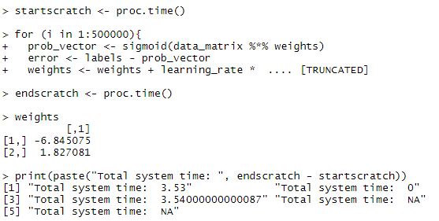  
This is the output of the R code (Logistic Regression)

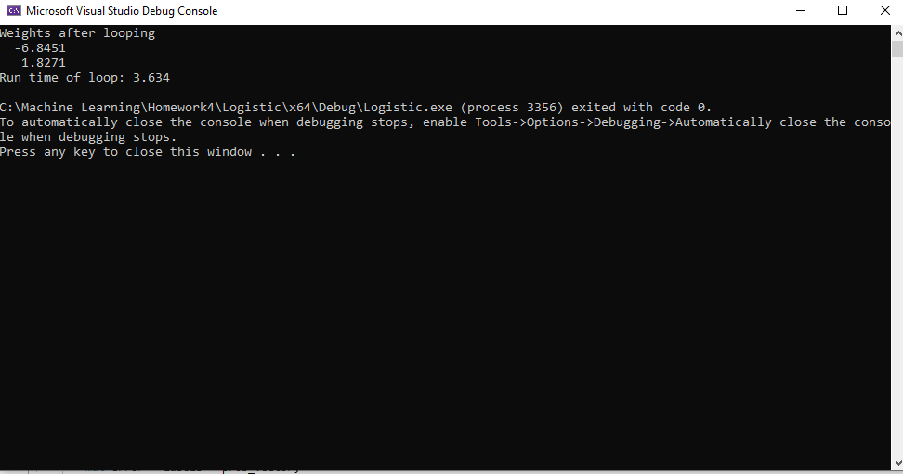This is the output of the C++ code (Logistic Regression)

CODE USED FOR TRAINING:

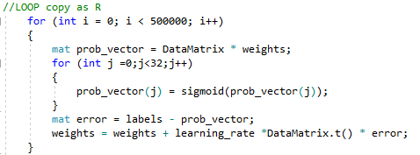

**NAIVE BAYES**

For the Naive Bayes in R I used the way we did it in our old homeworks (using predict,confusionMatrix() and etc) to print out all the results. However, the timing for this project I simply did it on basically the entirety of the program (minus the reading in of the .csv file). I only choose to attach photos related to the machine learning loops (so there are not photos of the plots I used)

This is the output of R (Naive Bayes)

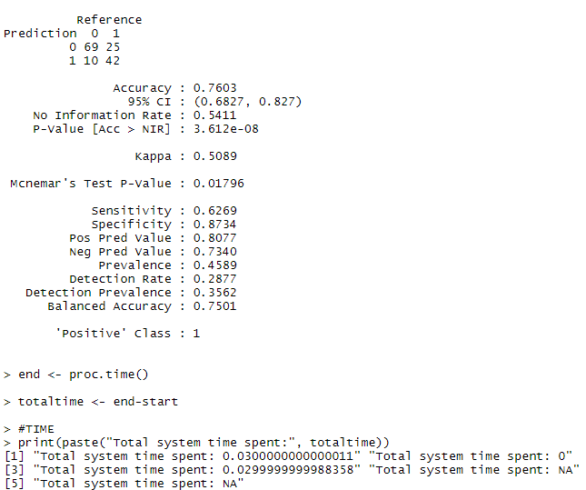

**REFERENCES**

* <https://www.youtube.com/watch?v=r1in0YNetG8>

* All pdf and GitHub examples from Piazza

* StackOverflow

* <https://solarianprogrammer.com/2017/03/24/getting-started-armadillo-cpp-linear-algebra-windows-mac-linux/>

* <http://arma.sourceforge.net/docs.html>